Boston Synchronized Skating Classic
Vendor Application

Friday/Saturday, November 15/16, 2019
New England Sports Center, 121 Donald Lynch Blvd, Marlborough, MA

Company/Name:________________________________________________

Address:______________________________________________________

City: ____________________________________ State: _______________

Email:________________________________________________________

Phone: ________________Contact Name: __________________________

Description of products to be sold: ________________________________

____________________________________________________________

____________________________________________________________

Need access to electricity? Yes_____ No ______
(please bring your own extension cord/s)

Table Configuration Option (see accompanying diagrams)
#1 ($125)____ #2 ($175)____ #3 ($250)_____ #4 ($325)____

Please mail completed Vendor Application and check for appropriate amount payable to Team Excel to:
Deanne Benson
115 Guggins Lane
Boxborough, MA 01719
Vendor application deadline November 1, 2019
Questions: contact Deanne Benson at
chair@bostonsynchroclassic.com

Vendor Table Configuration Options

Option #1:
One 8’ table
$125
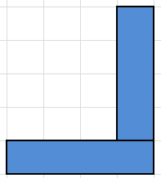 | Option #2:  Two 8’ tables  $175
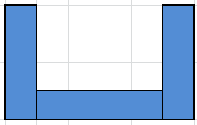 | Option #3:  Three 8’ tables  $250
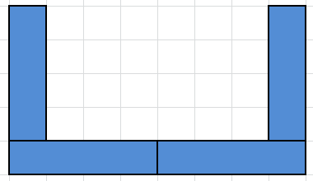 | Option #4:  Four 8’ tables  $325

