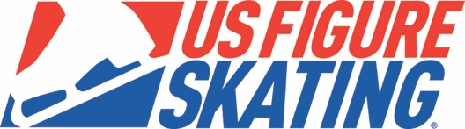

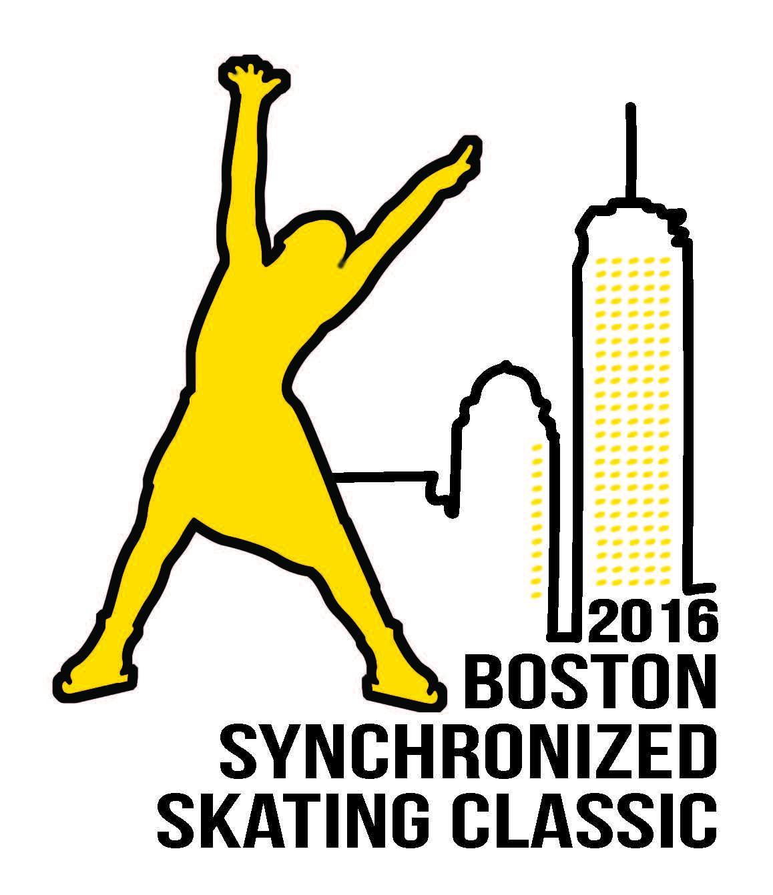
Hosted by Team Excel and The Skating Club of Boston
November 18-19, 2016

The 2016 Boston Synchronized Skating Classic will be conducted in accordance with the rules and regulations of U.S. Figure Skating, as set forth in the current Rulebook as well as any pertinent updates which have been posted on the U.S. Figure Skating web site.

This competition is open to all synchronized teams comprised of members who are eligible, restricted, reinstated, or readmitted persons, as defined by the Eligibility Rules, and currently registered members of a U.S. Figure Skating member club, a collegiate club or an individual member in accordance with the current Rulebook. Refer to the current rule book regarding eligibility of non-U.S. Citizens.

This event is proud to participate in the Eastern Synchronized Skating Challenge Series. Participation in this series is open to all Synchro Skills 1, 2, or 3 teams and preliminary, pre-juvenile, juvenile and open juvenile teams. Visit www.usfigureskating.org for more information on this series. Results of this event for participating teams will be reported to U.S. Figure Skating for calculation of the series results.

ELIGIBILITY / TEST AND AGE REQUIREMENTS: Skaters must meet the age requirements by the July 1st preceding this competition. This competition is not requiring that Moves in the Field test requirements be met, with the exception of the maximum allowed at the Learn to Skate USA level.

ENTRIES: All applications must be received by September 19, 2016. Early applications have a deadline of September 12, 2016. Applications should be entered online at: Entryeeze [www.entryeeze.com]

The entry fee is $230 per event plus $27 per skater, including alternates. The entry fee for Synchro Skills levels is $60 per team plus $12 per skater. Combined fee for Junior and Senior teams entering both the short and long program is $320 per team plus $27 per skater, including alternates. Early applications (received by September 12, 2016) receive a $25 discount off team entry fee.

We will use Entryeeze for on-line registration and payment. You must register and pay on-lne, which will include a nominal processing fee. Go to Entryeeze [www.entryeeze.com] to access the competition registration. A link to the online registration is also available on the competition website [www.bostonsynchroclassic.org].

Late entries will be accepted at the discretion of the chief referee. We reserve the right to combine, separate, or eliminate categories.

Synchro Skills 1-3 events will be run in accordance to the 2016-17 Learn to Skate USA Competition Manual (a maximum of 6 teams per group).

For Synchro Skills 1-3, if a team fits into one level age-wise, but would like more of a challenge, they may “skate-up” one level (for example, team has majority of skaters under 9 years old but would like to skate in the Synchro Skills 2, they may do so).

If you have questions, please email: info@bostonsynchroclassic.org.

REFUND POLICY:
Entry fees will not be refunded after September 19, 2016 unless the competition is canceled. The online processing fees are not refundable. Checks returned for non-sufficient funds and contested credit card charges will be assessed a $25 fee. Payment of the fee will be required before the team is allowed to participate in practice ice or events.

FACILITIES: The competition will be held at New England Sports Center (www.nes.com), 121 Donald Lynch Boulevard, Marlborough, MA. The competition rink is 200 feet by 85 feet, with 20-foot radius corners. The rink temperature is often cold. There is a snack bar at the competition rink. Locker rooms will be assigned upon arrival.

MUSIC: Only CDs (standard Compact Disk format) will be accepted. CDs must be clearly marked with name, event entered and the music length, and must be contained in a hard-sided “jewel” case.

Due to compatibility and reliability reasons no music may be submitted on re-recordable “CDRW” discs.

The official competition music must be turned in at the registration table at the time of check-in. A duplicate CD should be readily available. Music may be picked up at the registration table following each event. Every reasonable care will be taken, but Team Excel and The Skating Club of Boston cannot be responsible for CDs left at the end of the competition.

PLEASE HAVE SEPARATE CD’S FOR PRACTICE AND COMPETITION. Teams must also have an extra copy available at rink side during the actual competition event.

LIABILITY: U.S. Figure Skating, The Skating Club of Boston, Team Excel, and New England Sports Center accept no responsibility for injury or damage sustained by any participant in this competition. This is in accordance with Rule 1600 of the official U.S. Figure Skating Rulebook.

JUDGING SYSTEM: The International Judging System (IJS) will be used for the following events:
- Juvenile
- Intermediate
- Novice
- Junior Short Program & Free Skate
- Senior Short Program & Free Skate
- Collegiate
- Adult

The majority 6.0 Judging System will be used for the following events:
- Synchro Skills 1-3
- Preliminary
- Pre-Juvenile
- Open Juvenile
- Masters
- Open Adult
- Open Masters
- Open Collegiate

All teams competing in a level judged under the IJS will be required to complete a Planned Program Content Sheet. Each team’s Planned Program Content sheet must be completed via their Member’s Only profile at www.usfsaonline.org at least 7 days before the start of the event.

REGISTRATION: Registration will begin on Friday, November 18, one hour before the first practice ice of the day and will remain open through the end of the last competition event/practice ice on Friday evening; registration will re-open Saturday, November 19, one hour before the first practice ice of the day and will run through the last event of the day. The registration table will be located in the rink lobby. One team representative should register on behalf of the team, as soon as the team arrives at the competition. Coaches must register separately to receive their credential (see coaching requirements below). Teams should register and submit their music 2 hours before the start of their event.

ADMISSION: Each skater, including alternates on a competing team, will be provided with a competitor’s pass. In addition, each team will be issued passes for two team chaperones and two coaches per team. All-event tickets will be available at the door at a cost of $15 per adult and $5 for children under the age of twelve, seniors (65+), and members of the military. There will be no charge for children age two and younger.

PRACTICE ICE: Practice ice will be available Friday afternoon and evening and possibly Saturday morning. Practice ice should be requested through Entryeeze (www.entryeeze.com) and availability will be determined after the close of entries. All practice ice sessions will be held at New England Sports Center, in the same rink as the competition (see dimensions earlier in this announcement). Practice ice schedules will be emailed once available. The fee for practice ice is $90 per 10-minute session. Teams competing under the IJS system are required to purchase competition practice ice and will be grouped together. IJS practice segments will be 10-minutes long at a cost of $90, with the exception of Junior free skate, Senior free skate, and collegiate, which will have 12-minute segments at a cost of $105. Only Junior, senior and Collegiate teams may purchase 12-minute practice sessions.

AWARDS: Medals will be awarded to all skaters and alternates for first, second, third and fourth place teams. If the number of entries necessitates preliminary rounds, medals will be awarded to the first through fourth-place teams in the final round. The Junior and Senior short program and free skates are considered separate events. Results will be posted in the lobby, and awards will be given out off-ice at intervals during the competition.

OFFICIAL NOTICES: An official bulletin board will be maintained at the registration desk. It is the responsibility of each competitor, parent, and/or coach to check the bulletin board frequently for any schedule changes and/or additional information. Skaters are requested to arrive 45 minutes prior to the scheduled time of their event. The official schedule of events will be posted no later than 14 calendar days prior to the commencement of the competition.

INFORMATION REGARDING COACHES:

To coach at a U.S. Figure Skating nonqualifying competition, a professional coach or choreographer must be:
- Declared by the skater or team in the registration process
- Listed as Coaches Education Requirement (CER) Category A or B for the current
Season. If coaches are ONLY coaching a Learn to Skate USA Synchro Skills 1-3 team, a Learn to Skate USA Instructor Membership and background check is sufficient. If the coach is coaching any other level team(s) at a nonqualifying event, then he/she must have at least CER B for the current season
- Current with Coach Registration (requires annual fee and background check)
- A current member in good standing with U.S. Figure Skating

A coaches’ requirements chart can be found here: http://www.usfigureskating.org/Content/Coaches%20Requirement%20Chart.pdf.

The local organizing committee/club will have a list of coaches who are cleared for a credential at the competition. Coaches will need to check in at the event registration desk and show a government issued photo I.D. to receive a credential. Coaches who are NOT on the list will need to show proof of membership in U.S. Figure Skating, a Coaches Registration card, proof of Category A or B compliance, and a photo I.D. at check in. If a coach cannot provide a photo I.D. and is not on the list or cannot produce the necessary documents, he or she will not be allowed a credential – no exceptions. We strongly urge all coaches to have their cards with them. Non-credentialed coaches will not be permitted in the designated coaching area at rink side during events including practice sessions.

CONTACT INFORMATION:
Competition web site: www.bostonsynchroclassic.org
For questions, please contact the following individuals:

Competition Chair: Deanne Benson, chair@bostonsynchoclassic.org, 978.263.0323
Chief Referee: Judy Edmunds, judyedmunds@gmall.com, 508.775.9303
Practice Ice: info@bostonsynchroclassi.org

ADDITIONAL INFORMATION: Judges critiques will be provided. Information will be available at the registration desk.

ACCOMMODATIONS: The 2016 Boston Synchronized Skating Classic has contracted group rates at several local hotels. Please contact each hotel directly and mention the Boston Synchronized Skating Classic for the competition rate.

Best Western Royal Plaza (5 miles from competition rink)
181 Boston Post Road West
Marlborough, MA 01752
508-460-0700
$149/night + tax (includes breakfast)
Book by 10/28/2016

Courtyard Boston Marlborough
75 Felton Street
Marlborough, MA 01752
508-480-0015
$148/night (includes breakfast for 2) – Discounted rate based on a two week advanced payment in full (11/4/16). This advance payment is non-refundable or changeable within the two week window.
Book by 10/21/2016

Embassy Suites (7 minutes to competition rink)
123 Boston Post Road West
Marlborough, MA 01752
508-485-5900
Contact: Jennifer Mello, Group Sales Manager
Jennifer.Mello@hilton.com
$139.95/night King
$154.95/night Double
Book by 10/18/2015

Residence Inn by Marriott Marlborough
112 Donald Lynch Blvd.
Marlborough, MA 01752
508-481-1500
$189/night one bedroom suite or studio suite (breakfast buffet included)
2 night minimum stay
Use group code BSSP/Sports/Team
Book by 10/2192015

TRANSPORTATION: Free parking is available at New England Sports Center. Information about bus parking will be sent to teams prior to the competition. New England Sports Center is approximately one hour from major airports in Boston (MA), Providence (RI), and Manchester (NH).

TENTATIVE SCHEDULE: A tentative schedule will be posted on the website (www.bostonsynchroclassic.org) as soon as it is available.

EVENTS OFFERED:
See the current rulebook/website for current rules and ISU communications.
http://www.usfigureskating.org/New_Judging.asp?id=361)

Illustration of Synchronized Skating competitive pipeline and events; age restrictions, test requirements, and program duration are on the next page:
Synchro Skills 1

Learn to Skate USA/
Introductory Events
Synchro Skills 2

Synchro Skills 3

Preliminary
Developmental /
Nonqualifying Events
Pre-Juvenile
Open Juvenile

Junior
Novice
Intermediate
Juvenile
Senior
Competitive Events

Open Collegiate
Collegiate
Collegiate Events

Masters
Open Masters
Open Adult

Adult Events

Adult

A. Synchro Skills 1: A team of 8 to 16 skaters. The majority of the team must be under 9. No skaters may have passed higher than a preliminary test.
Program duration: 1 ½ -2 minutes.
Rules: http://www.usfigureskating.org/programs?id=84096&menu=synchronized

B. Synchro Skills 2: A team of 8 to 16 skaters. The majority of the team must be 9-11 years old. No skaters may have passed higher than a preliminary test.
Program duration: 1 ½ -2 minutes.
Rules: http://www.usfigureskating.org/programs?id=84096&menu=synchronized

C. Synchro Skills 3: A team of 8 to 16 skaters. The majority of the team must be at least 12 years old. No skaters may have passed higher than a preliminary test.
Program duration: 2 – 2 ½ minutes.
Rules: http://www.usfigureskating.org/programs?id=84096&menu=synchronized

D. Preliminary: A team of 8 to 16 skaters. All skaters must be under 12. The majority of the team must be under 10.
Program duration: 2 minutes.
Well balanced program: Rule 7270

E. Pre-Juvenile: A team of 8 to 16 skaters. The majority of the team must be under 12.
Program duration: 2 minutes, 15 seconds.
Well balanced program: Rule 7260

F. Open Juvenile: A team of 8 to16 skaters. Skaters must be under 20 and have passed the pre-preliminary moves in the field test.
Program duration: 2 ½ minutes.
Well balanced program: Rule 7250

G. Juvenile: A team of 12 to 20 skaters. Skaters must be under 13 and have passed the preliminary moves in the field test.
Program duration: 3 minutes.
Well balanced program: Rule 7240

H. Intermediate: A team of 12 to 20 skaters. Skaters must be under 18 and have passed the pre-juvenile moves in the field test.
Program duration: 3 ½ minutes.
Well balanced program: Rule 7230

I. Novice: A team of 12 to 20 skaters. Skaters must be under 16, with the exception that up to 4 team members may be 16 or 17. All must have passed the juvenile moves in the field test.
Program duration: 3 ½ minutes.
Well balanced program: Rule 7220

J. Junior: A team of 12 to 16 skaters. Skaters must be at least 13 and under 19 on the preceding July 1. All skaters must have passed the intermediate moves in the field test.
Short program duration: Maximum 2 minutes, 50 seconds
Free skate duration: 4 minutes.
Well balanced program and short program: Rule 7210

K. Senior: A team of 16 skaters. Skaters must be at least 15 on the preceding July 1 and have passed the novice moves in the field test.
Short program duration: Maximum 2 minutes, 50 seconds
Free skate duration: 4 ½ minutes.
Well balanced program and short program: Rule 7200

L. Open Collegiate: A team of 8 to 16 skaters. Skaters must have a high school diploma or equivalent and be enrolled in a college or university as a full-time student, as of the entry deadline.
Program duration: 3 minutes.
Well balanced program: Rule 7290

M. Collegiate: A team of 12 to 20 skaters. Skaters must have a high school diploma or equivalent and be enrolled in a college or university as a full-time student, as of the entry deadline, and have passed the juvenile moves in the field test.
Program duration: 4 minutes.
Well balanced program: Rule 7280

N. Open Adult : A team of 8 to 16 skaters. The majority of skaters must be at least 19 years or older.
Program duration: 2 ½ minutes.
Well balanced program: Rule 7520

O. Open Masters: A team of 8 to 16 skaters. Skaters must be at least 25, and the majority of the team must be at least 30.
Program duration: 2 ½ minutes.
Well balanced program: Rule 7530

P. Masters: A team of 12 to 20 skaters. Skaters must be at least 25, and the majority of the team must be at least 30.
Program duration: 3 minutes.
Well balanced program: Rule 7510

Q. Adult: A team of 12 to 20 skaters. All skaters must be at least 21 with the exception that up to four team members may be 18, 19 or 20 years of age. All skaters must have passed either the preliminary moves in the field test, the adult bronze moves in the field test, the preliminary figure test or the preliminary dance test.
Program duration: 3 minutes, 15 seconds.
Well balanced program: Rule 7500

Teams are permitted to have a maximum for four alternates, in addition to the maximum number of athletes allowed on the ice at their level.

Crossover Rules:
No team may be comprised of more than 50% of athletes that are also on any other team. This applies to both the entire roster and the athletes that are skating on the ice at any given competition.

The chart below illustrates the levels where crossover skaters are allowed. The shaded areas indicate no crossovers are allowed. An “X” indicates crossovers are allowed between the two levels, providing all requirements are met as defined Rules 7200 – 7530, in addition to the statement above.

 | Synchro Skills 1, 2 or 3 | Preliminary | Pre -Juvenile | Open Juvenile | Juvenile | Intermediate | Novice | Junior | Senior | Open Collegiate | Collegiate | Open Adult | Open Masters | Masters | Adult
Synchro Skills 1, 2 or 3
Preliminary
Pre - Juvenile
Open Juvenile
Juvenile |  |  |  |  |  | X | X
Intermediate |  |  |  |  | X |  | X | X | X
Novice |  |  |  |  | X | X |  | X | X
Junior |  |  |  |  |  | X | X |  | X |  | X
Senior |  |  |  |  |  | X | X | X |  |  | X |  |  |  | X
Open Collegiate
Collegiate |  |  |  |  |  |  |  | X | X |  |  |  |  |  | X
Open Adult
Open Masters
Masters |  |  |  |  |  |  |  |  |  |  |  |  |  |  | X
Adult |  |  |  |  |  |  |  |  | X |  | X |  |  | X

